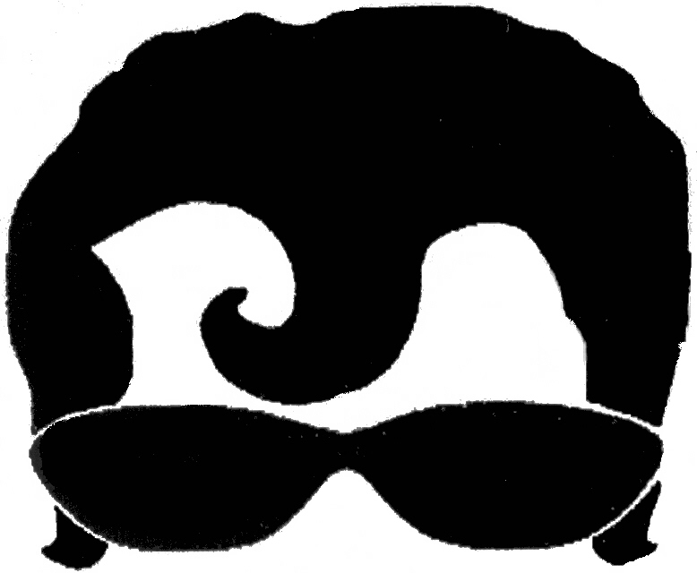
Boomer Band, LLC
(partial song set list)

Shake, Rattle, and Roll Bill Hailey
Jailhouse Rock Elvis
Hound Dog Elvis
Good Golly Miss Molly Little Richard
Johnny B. Goode Chuck Berry
What's Your Name Don & Juan
Great Balls of Fire Jerry Lee Lewis
Yakety Yak Coasters
Young Blood Coasters
Poison Ivy Coasters
Charlie Brown Coasters
In The Still of the Night The Five Satins
Somethin' You Got Big Jay McNeely
Rock Around the Clock Bill Hailey
Blue Moon Marcels
Daddy's Home Shep and the Limelites
The Twist Chubby Checkers
Finger Poppin Chubby Checkers
Stagger Lee Lloyd Price
Louie, Louie The Kingsmen
Falling in Love Elvis
Twistin' the Night Away Sam Cook
At the Hop Danny and the Juniors
Teach Me Tonight Sammy Cahn
Mustang Sally Rufus Thomas
Ooh Poo Pah Doo Jessie Hill
The Name of the Place Charles Thompson
Lucille Little Richard
Any Way You Want It Jimmy Reed
Walkin' the Dog Rufus Thomas
Good Night Sweetheart Moonglows
Sea Cruise Frankie Ford
Peppermint Twist Joey Dee and the Starlighters
Summertime Blues Eddie Cochran
Little Darlin The Diamonds
Maybe The Chantels
Sick and Tired Fats Domino
Rockin' Robin Bobby Day and the Knights
Green Onions Booker T. and the MG's
Locomotion Little Eva
Sixteen Candles Crests
Slipin' and Slidin' Little Richard
Pretty Woman Roy Orbison
Buzz, Buzz, Buzz Hollywood Flames
Honky Tonk Bill Dogget

